Environment Position Perspective for the YMCA of GTA
- A funded approach using the “green giving” fund
By Alex Versluis, March 26, 2008

The YMCA of Greater Toronto has made a commitment to environmental stewardship. As a leader in the community for building connections, educating our youth, and helping to move our staff, members and volunteers through the continuum to better living we should strive to be leaders in this endeavor.

Some key thoughts about the environmental impact of our core services:

- HFR sites are heavy users of energy. This energy is used to heat and cool our air, it heats the water in our showers, it keeps the pools comfortable and safe. With our long work days and work weeks, most of our facility systems are on 24/7.

- Childcare sites consist of many small sites spread across our region with similar energy and resource consumption. Camp Pinecrest and Cedar Glen are outdoor education environments that not only promote learning and understanding nature, but should be driving the perpetuation of knowledge for how we take as little as we need from the earth, and ways to offset what we do take.

- E&C gives us access to a different segment of youth who are reconnecting with society and are learning how to live in today’s world. The immigrants that flow into our countries and programs are the foundation that have built our country’s fabric, and will continue to evolve our culture.

- Blending our environmental learnings into these programs in what is delivered, how it is delivered, and the places they are delivered lets them see, hear and feel the impact of true environmental stewardship.

Moving good intent into action is the trick with all things successful in life. We have moved into this direction in fits and spurts over the last many years. We need to turn the pressure full-on and create a sustainable current that captures our association in force.

There are many low-cost green initiatives that are building momentum in our association today. We are starting to reduce paper usage in our offices, offering bicycle parking, using biodegradable cups, and starting to recycle better. The Procurement team has been blending environmental stewardship into the services and products they offer to staff and our members.

While our facilities offer some of the greatest opportunities for conservation and the use of alternate energy sources, they also offer the greatest barriers.

The hardest part of moving from an inefficient building to one that has been renewed with a sustainable approach is the upfront capital costs.

I want to introduce the concept of a “Giving Green Fund” for donors to give, something that could be made part of the YMCA’s donor-centred giving strategy. I understand that traditional giving is directed to operational needs, to capital projects, or to an endowment fund. The endowment allows us to use the interest and keep the principal for future years and is a gift that keeps giving. This “giving green fund” concept flips this endowment approach on it head and works as follows:

We build a suite of initiatives that meet our key environmental values. People who give to this will be helping to fund projects that will create annual operational savings immediately. The operational savings are captured and redirected to assist programming AND be will be helping us reach our environmental goals.

The key message to these potential donors is they will invest in the preservation of the environment in their local community, conservation of our resources in our region and support the YMCA of GTA to build stronger, smarter and better people in their neighbourhood. This is the green gift that keeps giving.

Some of the risks that will need to be mitigated to this approach are:

RISK 1 - Nobody gives to this fund
I would recommend we start with a 5 to10–year net payback at the fund level for the first two years as we build momentum. We will also encourage technology partners to donate a portion of their equipment to improve the overall business cases.

RISK 2 - We make poor technology selections
Business being business, the many vendors in the marketplace created different vehicles to help organizations like ours bridge the financial gap by “guaranteeing” savings. While this works for some organizations, the reality is the vendor is getting paid well to prepare a conservative analysis. In my opinion, our approach should be to perform the due-diligence to gain the necessary understanding and save the insurance payments for better uses.

We should manage this risk with good partners and management. Many of these relationships exist, but care will be taken to make smart choices and to avoid cutting edge technologies that are as yet unproven.

RISK 3 – Not capturing the budget savings
This has to be built into the budget-planning and reviews. I have already started baselining the utility consumptions, so we can use that as the guide.
The following is an outline for the roadmap to build this vision:

Action 1: Identify the key goals of this program

David Rourke has spent time thinking and filtering these goals into four main themes, which I represent with minor adjustments:
- Energy Management
- Waste Management
- Emission Control
- Sustainable Resource Management

Next Step: These themes and the concept of this outline need to be put to the user group for feedback. This should include further consideration on the key values we want to live by.

Action 2: Identify and enlist industry partners

Once we have our key vision developed, we should find a partner consultant that has a deeper experience in moving organizations through the continuum of change. We should build a path that meets our overall environmental vision as well as industry standard ranking such as LEED and GO Green (formerly GreenGlobes) to demonstrate our commitment and ability to meet and exceed these goals.

Action 3: Identify the key deliverables for each theme

As part of the tactical measures we select, we should build business cases around the four themes. The cases will often not make business sense in the traditional definition, but still meet the intent of our key values.

From my perspective, I believe the following should be tackled by Key Theme:

A. Energy Management

As mentioned in the opening, the HFR sites are heavy users of energy and resources. Since our buildings were mainly constructed in an era where energy and resource use were not a priority, our older facility systems are inefficient as compared to modern systems, and have degraded over time. Our newer sites have incorporated newer technologies with growing success, proportional to the evolution of the industry. The non-HFR sites have varying degrees of efficient systems depending on the approach of the owner, age of the facility and systems. The camps are a different animal altogether and require custom strategies.

The true opportunity is renewing our inefficient systems at the end of their useful lives. It is always best to start with reducing energy and resource use, then later explore alternative ways to consume.

Some examples of these initiatives are as follows:

Improve lighting technology and the use of lighting:
Our owned sites (or those that we are responsible for the light fixtures) that have older and inefficient lighting systems need to be updated to more efficient lighting. For sites we lease, we need to encourage our landlords to move to more efficient systems. We may choose to share costs of upgrading the lighting with landlords if we are paying for the use of electricity.

As an example, we have been using Compact Fluorescent Lights (CFLs) in “pot-light” style fixtures for years. In addition, we have just started replacing EXIT sign lighting with LED bulb technology that uses a fraction of the energy (saves > 60% electricity) and has a whole cost payback of 2 years.

Other areas that we are moving are:
- Upgrading T12 fluorescent lighting to T8 lighting. The electricity savings are closer to 30%, and allow us to reuse many elements of the existing fixture. This can be further reduced by using light sensors that dim or turn off lighting on sunny days. Using that natural lighting in many of these areas will actually save on cooling costs, since these light fixtures emit heat. These initiatives are still in the exploratory stages and paybacks have not yet been calculated. Typically these are in the 3 to 5 year range.
- Motion & proximity sensors on lights located in spaces that are intermittently used like washrooms, mechanical rooms, maintenance closets, office spaces, etc. This can also apply to exterior lighting. The payback on these are often less that a year in cases where the lights are left on with nobody around.

Improve the Heat Recovery of the facilities:
Many of our sites waste heated air through exhaust fans, and waste heated water through drain lines. We have some instances of heat-recovery that we have blended into the renewal of our systems, but we are now starting to move more aggressively to identify these areas and design/cost the solutions. We have just completed a study at Scarborough YMCA with a payback of about 6 years to add heat recovery. We are also in the midst of one at Metro Central to find and plan a turn-around strategy. Paybacks typically vary from 2 to 10 years.

Improve the Electrical Distribution:
Our larger sites are penalized for the high amount of electricity usage, especially at peak times. There are further penalties for poor distribution/transfer of the electricity into the buildings. We have identified many of the culprits and are designing/costing the solutions. Paybacks vary from 4 to 10 years.
Reduce Water Consumption:
The FM committee is actively pursuing alternatives to saving water in a manner that has a minimal impact to our members. We are moving to low-flush toilets, shower heads and faucets that are activated by motion. We are exploring the use of timed showers in family change rooms where showers are often left running. All sites across the YMCA of Greater Toronto can benefit from these standards, yielding a larger overall impact.

B. Waste Management

The waste management opportunities include the improvement of our garbage and recycling processes. The procurement team has provided the infrastructure for our facilities to remove properly sorted waste, but our bins and processes for gathering that waste need a proper plan. David Rourke and I have been working towards some recycling and garbage bin standards, but this is still a work in progress. Below is an abstract.

Recycling & Waste Disposal Standard for the YMCA of Greater Toronto:

Objective: To help our members and staff make the best choice for depositing waste. Our successful approach will allow the maximum use of our recycling services in an easy and intuitive way, minimizing cross-contamination of litter, and keep our buildings beautiful.

Relevance: This standard applies to all YMCA of Greater Toronto sites and buildings.

Approach: Overall, we will use some simple rules based on the use of the area. Special facilities and sites will be discussed in detail. It is critical to keep all walkways clear of bins to enable a clear path in the event of a fire or other emergency.

Other opportunities that are being explored, but require further thought include:

Use of containers from suppliers: this includes how our consumables, cleaning supplies, food and other like products are packaged, delivered, and disposed of. An example of a recent success is the laundry cleaning chemicals. We have just converted our commercial-level laundry sites to an Eco-Lab product that uses small containers that are fully cleaned and recycleable. The system is easier and safer for our staff to handle as it replaces the 50-gallon drums. These drums were treated as hazardous waste due to the size and type of materials that were transported.

Renovation Debris - materials handling: this included items like carpet and concrete being removed. We need to consider this approach when preparing the scopes of renovation projects and understanding the impact beyond the bottom line.

One of the successes that we want to build on is using a carpeting supplier such as Interface, that supplies a carpet manufactured with recycled rubber. Not only do they include the cost of removing their product from our building and recycling it, they also take a complete lifecycle approach to their business by offsetting their carbon footprint created through their manufacturing processes. A sample of their certificate is:
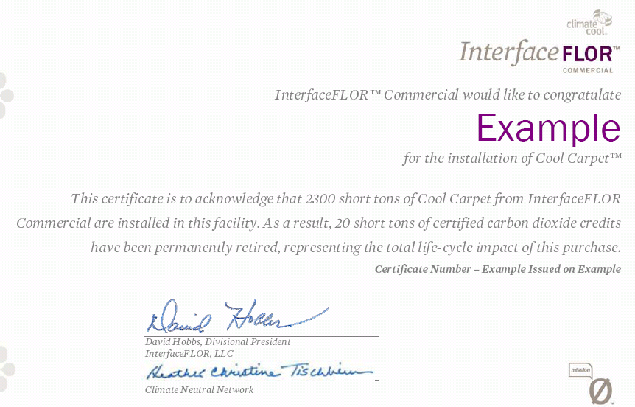

Reducing paper usage
During the month of October, 2009, the YMCA of Greater Toronto ordered 517,000 sheets of paper. Using October as an average month, and projected this usage over a calendar year, our association uses 6, 204,000 sheets of paper in 365 days. That is equal to roughly 745 trees a year…and this is only on printer and copier paper!

C. Emission Control

This is an element to our plan that requires more thought. Some of the areas that we have discussed include managing the amount and quality of exhaust from our heating systems, understanding what we are putting down our drains, dealing with our sites that have environmental contamination, the impact of salts as a de-icer, understanding the impacts of the chemicals we use in and on our facilities.
D. Sustainable Resource Management

Using our resources to improve the way we generate power, heat & cool our facilities systems, and even the selection of the materials that we choose to put into our buildings all fall within this category. Some of the key items that we have researched with respect to facility construction and renewal include:

Using the sun to create energy:
This comes in a few forms, but the most cost-effective variation is solar heating of water for pools, showers, and heating. Using the sun in this manner allows us to reduce the amount of gas consumption in the summer months, reduces the emissions that we burn, and is something that can be seen and appreciated. The HFR sites are ripe for this technology due to the high consumption of water to provide our services.

In addition to solar heating, photovoltaic power, which converts the sun’s energy to electricity, is being used in a few locations. Overall, our current installations are unsuccessful. This technology has gone through many iterations of improvement, and will continue to do so. There are some technologies that blend photovoltaic with solar heating to yield a more efficient solution.

We have started to explore this technology for sites like Metro Central, where the rooftop track has a large space to capture the sun’s rays and could easily be converted to an educational experience for our members and community to see how it works. It is a great opportunity for partnering with technology firms to donate a portion of their technology to be a part of a community centerpiece.

Using the earth to create energy:
Geothermal technologies are no longer cutting edge, but are now commercially available with a track record. This technology uses the earth’s thermal mass to return cool water back to the facility to generate both heated and cooled air through heat pumps. Cedar Glen has the potential to be a very good fit for this technology since the residential buildings use electricity, have poor air quality in the summer, and the site is located on a large piece of land. We are in the midst of the feasibility study to evaluate this technology for this site, and indications look very good. With Cedar Glen’s vision to create an earth-friendly educational experience for campers and conference goers, this type of system could help to boost that strategy.

Other Items that we should explore include:
- Hybrid vehicles for Cedar Glen and Camp Pine Crest
- Offsetting the YMCA of Greater Toronto’s carbon footprint, or selling the rights if we create a net savings?
- Additional forms of alternate energy like wind
- Using consumables that biodegrade and are made in a sustainable way

